**LAB REPORT NO 2**



**Spring 2020**

**CSE-202L Digital logic design lab**

Submitted by:  **Muhammad Ali**

Registration No:- **19PWCSE1801**

Class Section: A

“On my honor, as student of University of Engineering and Technology, I have neither given nor received unauthorized assistance on this academic work.”

Submitted to:

**Engr. Abdullah Hamid**

(December 19, 2020)

Department of Computer Systems Engineering

University of Engineering and Technology, Peshawar

***Lab 3***

**De-Morgan’s Theorem**

# OBJECTIVE

After completing this experiment, you will be able to:

▪ Experimentally verify the De-Morgan’s theorems using two input variables

# COMPONENTS REQUIRED

* 7432 quad 2-input OR gate
* 7404 hex inverter
* LED
* 7430 quad 2-input AND gate
* DIP switch
* Three 1 kΩ resistors

# DE-MORGAN’S THEOREM

* (X + Y)’ = X’. Y’ ............ (a)
* (X. Y)’ = X’ + Y’............ (b)

# PROCEDURE

* Build the circuit for left part of equation (a) as shown in figure 3.1 and monitor the behavior of LED for different test inputs
* Then complete the circuit of figure 3.2 for the right part of equation (a) and complete the truth table 3.1 by testing each combination of inputs of appropriate switches
* Compare both the column results and check whether equation (a) is verified or not
* Repeat the above process by building the circuits of figure 3.3 and 3.4 and comparing its results for De-Morgan's theorem verification of equation (b) .

1

# DE-MORGAN’S THEOREM

(X+Y)’= X’. Y’ ………………….. eq. A

# For left hand side of equation (A):-

# logic circuit diagrams:-

1

2

3

2

1

K

**+**

**5 V**

**X**

**Y**

1

K

K

1

**+**

**5 V**

**Fig**

**. 3**

**.1:**

**Circuit for**

**(**

**X+Y)’**

**Experimental circuit:-**

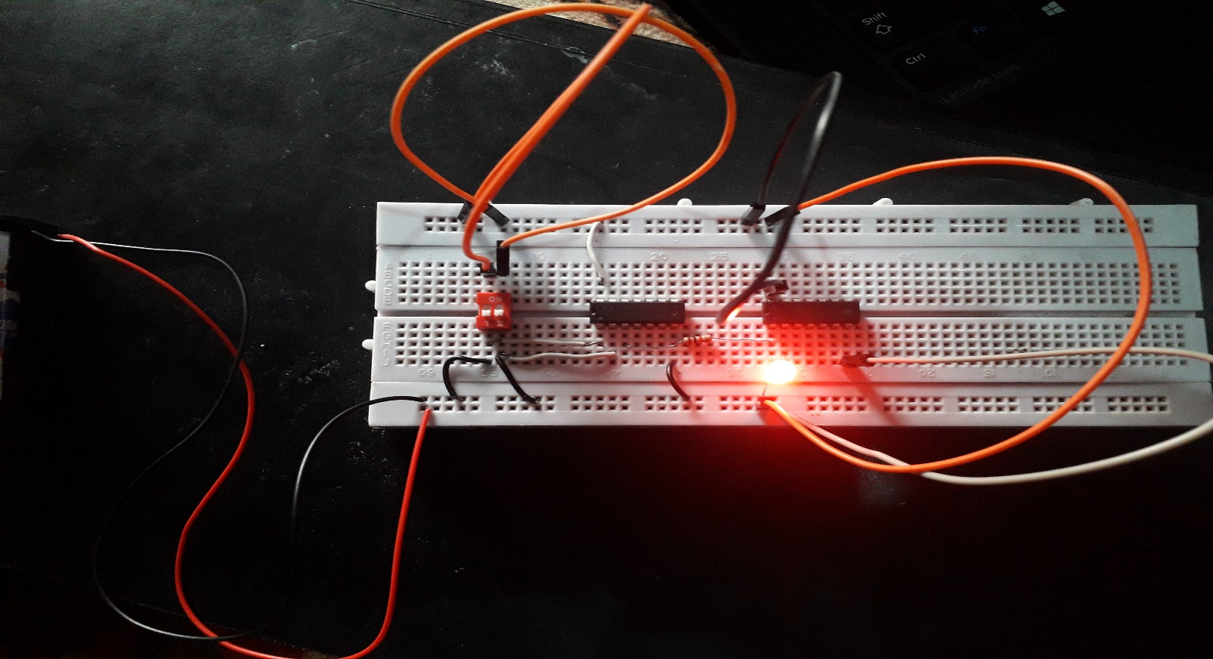

# For right hand side of equation (A):-

# logic circuit diagrams:-

1

K

**X**

**Y**

K

1

K

1

1

2

3

4

1

2

3

**Fig**

**. 3**

**.2:**

**Circuit for**

**X’ . Y’**

**Experimental circuit:-**

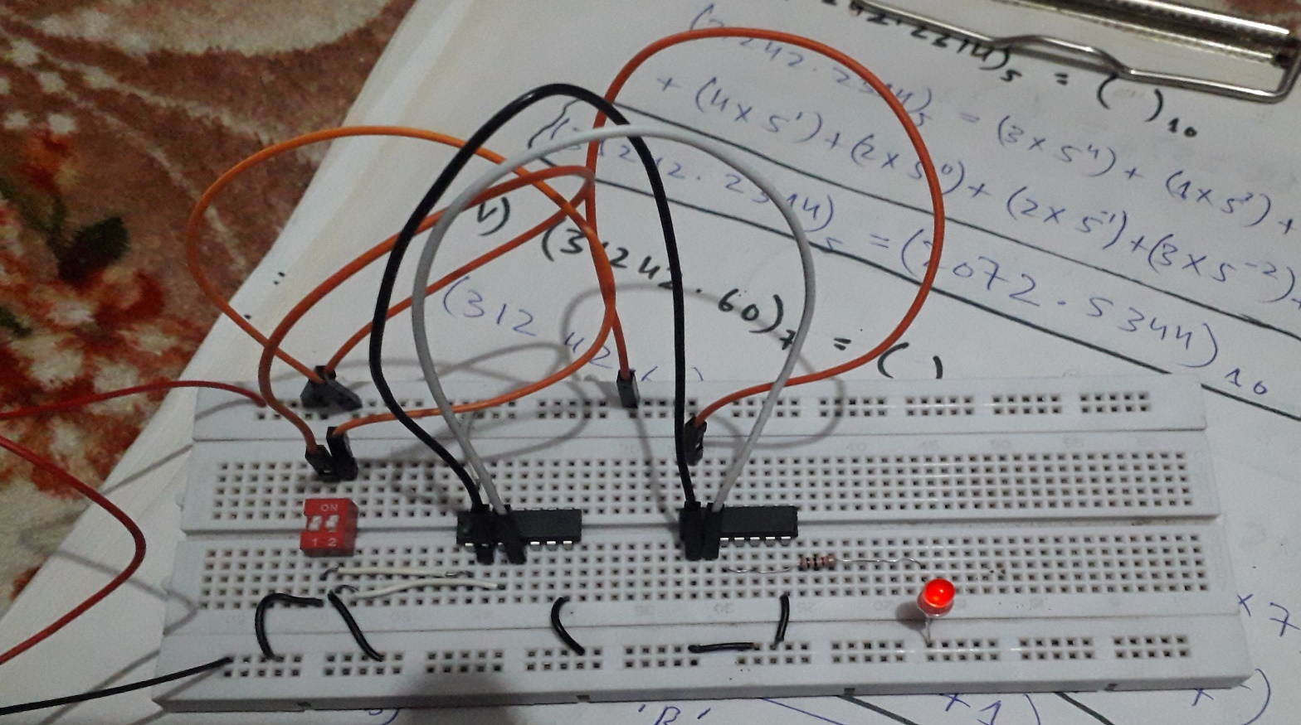

**Experimental verified truth table:-**

|  |  |  |  |
| --- | --- | --- | --- |
| **X** | **Y** | **(X + Y)’** | **(X’ . Y’)** |
| **0** | **0** | 1 | 1 |
| **0** | **1** | 0 | 0 |
| **1** | **0** | 0 | 0 |
| **1** | **1** | 0 | 0 |

2

# DE-MORGAN’S THEOREM:-

(X.Y)’= X’+Y’ ………………….. eq. B

# For left hand side of equation (B):-

# logic circuit diagrams:-

1

2

K

1

**+**

**5 V**

**X**

**Y**

1

K

1

K

1

2

3

**Experimental circuit:-**

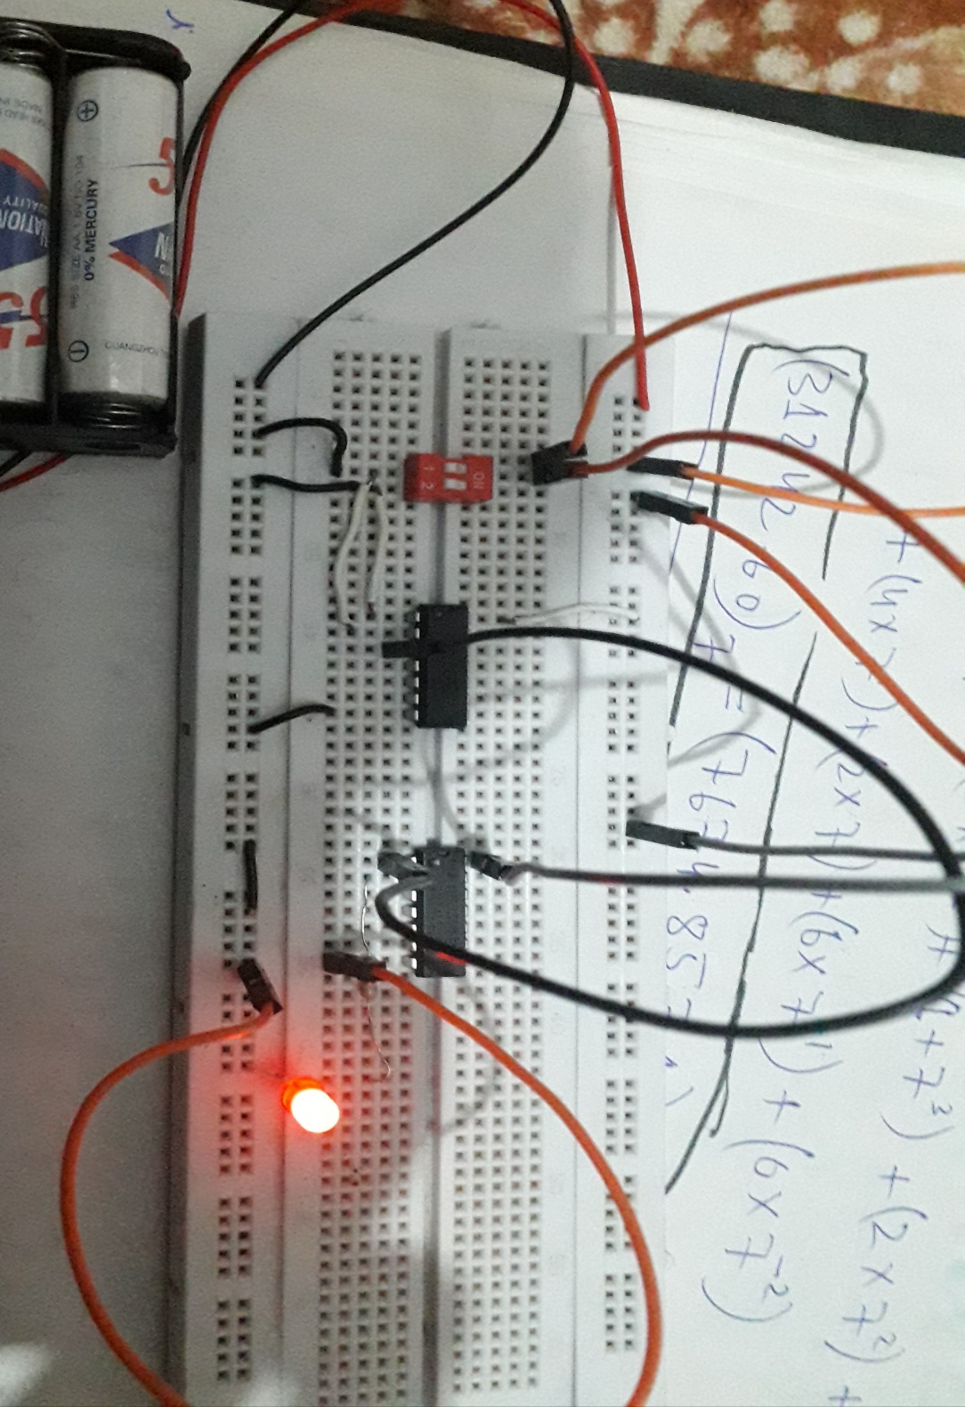

# For right hand side of equation (B):-

# logic circuit diagrams:-

## Fig. 3.3: Circuit for (X.Y)’

**Fig**

**. 3**

**.4:**

**Circuit for**

**)**

**X’ + Y’**

**(**

K

1

**5 V**

**+**

**X**

**Y**

K

1

K

1

1

2

3

4

1

2

3

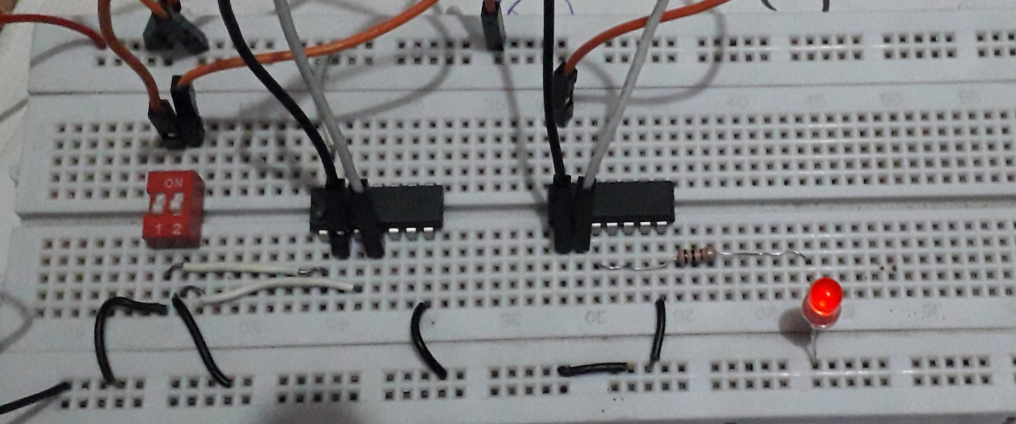

**Experimental circuit:-**

|  |  |  |  |
| --- | --- | --- | --- |
| **X** | **Y** | **(X . Y)’** | **(X’ + Y’)** |
| **0** | **0** | 1 | 1 |
| **0** | **1** | 1 | 1 |
| **1** | **0** | 1 | 1 |
| **1** | **1** | 0 | 0 |

3

# REVIEW QUESTIONS

▪ Simplify the expression using De-Morgan's theorems and verify the two expressions experimentally.

## F= ((A . B)’ + A)’

**Simplification:-**

## F= ((A . B)’ + A)’

= ((A.B)’)’.A’)

= A.B.A’ (A.A’=0)

= 0.A

=0

**Experimental citcuit:-**

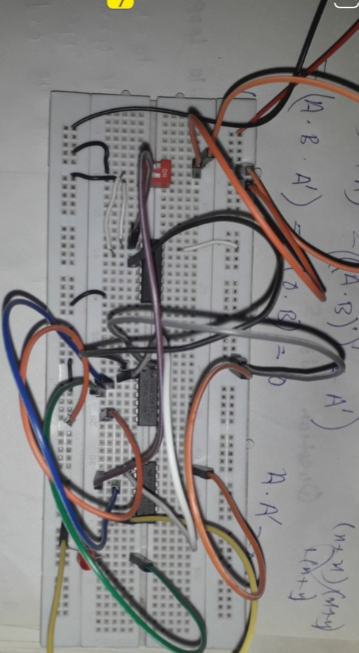

▪ Determine experimentally whether the given circuits are equivalent. Then use DeMorgan’s theorem to prove your answer algebraically.

**Experimental circuit:-**

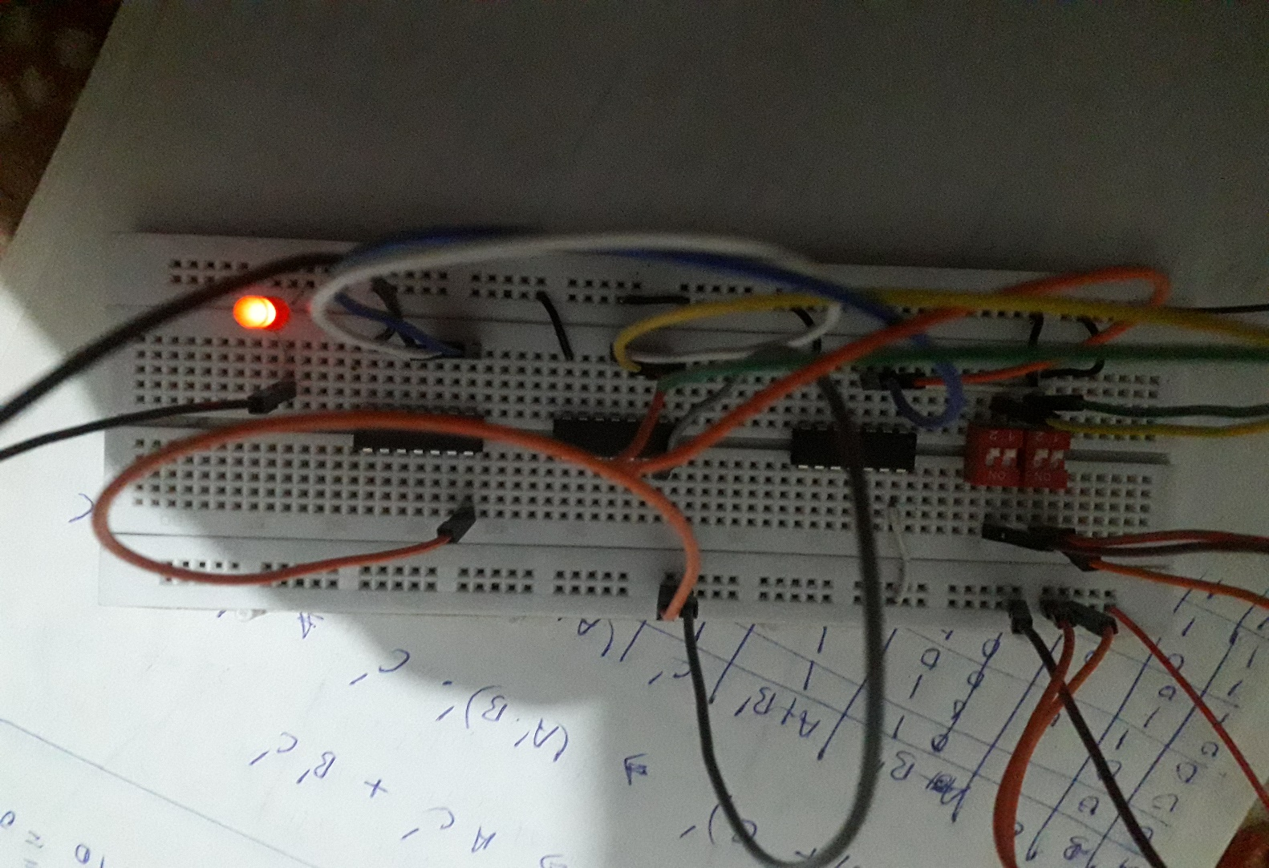

**Expressions:-**

**1. (A+B’).C’**

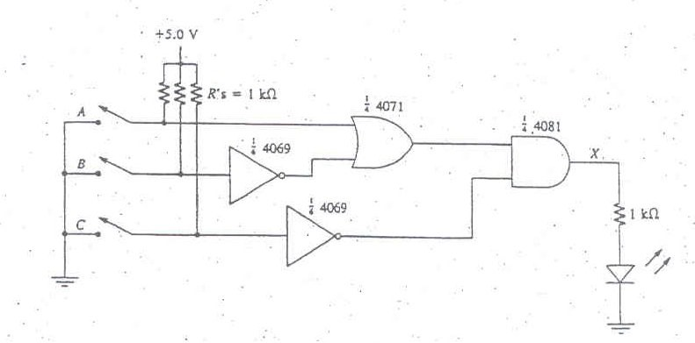

**2. ((A’.B)+C)’**

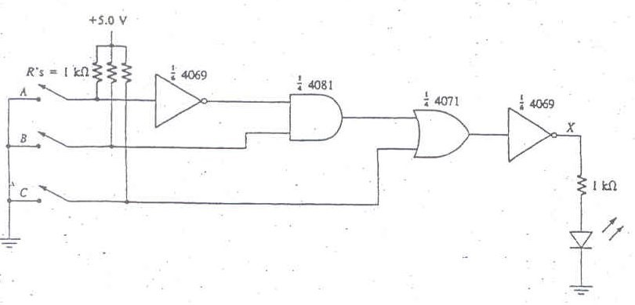

**Algebraically:-**

**1st expression:-**

(A+B’).C’ = A.C’+B’.C’…………….A

**2nd expression:-**

((A’.B)+C)’ = (A’.B)’.C’

= A+B’.C’

((A’.B)+C)’ = A.C’+B’C’ ………………….B

**Hence proved both equations are equals algebraically**.